**Brooklyn torah gazette**

**For parshas Chaya sarah 5782**

Volume 6, Issue 6 (Whole Number 261) 24 Cheshvon 5782/ October 30, 2021

**Printed L’illuy nishmas Nechama bas R’ Noach, a”h**

For a free subscription, please forward your request to [***keren18@juno.com***](mailto:keren18@juno.com)

**For the Women,**

**By the Women**

**By Rabbi Osher Lemel Ehrenreich**

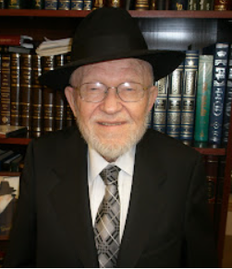 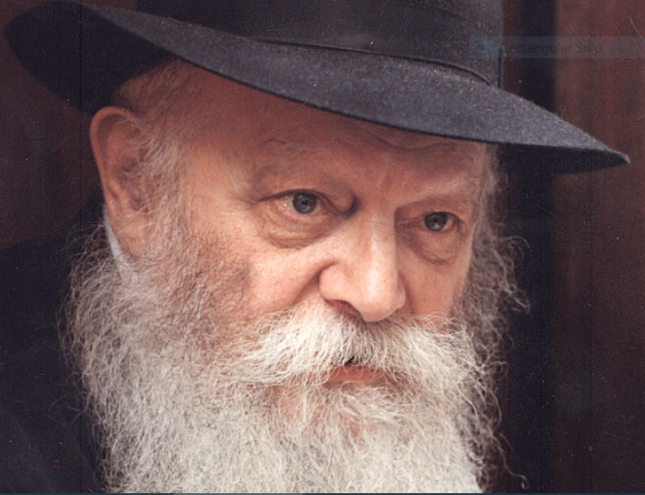

**Rabbi Osher Lemel Ehrenreich and the Lubavitcher Rebbe (Menachem Mendel Schneerson)**

In 1955, I became the principal of Bais Yaakov of Boro Park, a religious girls’ school, and in the sixty years since, I’ve had the exciting job of raising the daughters of Israel in the traditional Jewish way.

In those early years, I had a little office in our building on 45th Street, and people used to come in to *schmooze*. Once, Mr Rubashkin, a Chabad *chasid* who had children in our school, came by, and in the course of our conversation he suggested, “Why don’t you come to see the Rebbe?”

I don’t count myself as a Lubavitcher, but, there was no doubt in my mind that he was a great man, and I was very much interested in meeting with him. So, we set a date, and organized a little committee to go to the Rebbe.

It was about one o’clock in the morning when the four or five of us – faculty and supporters of the school – entered the Rebbe’s office.

The Rebbe welcomed us very graciously. He struck me as a real gentleman, a continental European of the old school. We presented a few issues of concern and he addressed each of them in turn.

When he started talking, I realized that, though I had heard him deliver addresses to the public before, this was the first time I had heard him speak in conversation and respond to questions.

It was obvious that he was brilliant – brilliant, but with two feet on the ground – and well thought out. Whatever we asked him, he gave clear, concise, and definite answers without hesitating or searching for words. There was also a lot of wisdom there, and sincerity too. No doubt, it was one of the outstanding experiences of my lifetime.

“In our times,” we asked the Rebbe, “what should be at the heart of education?”

There was a lot of change going on in those days. The 1960s saw a cultural revolution in America that brought havoc onto the world. The whole value system changed, the music changed, everything was turned upside down, and all the rules – including standards of modesty – went out the window. The aim of society became all about meeting one’s desires, which stands counter to the values of Judaism.

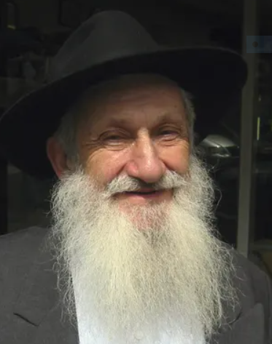

**Reb Aharon Rubashkin**

**The Main Emphasis Should be Love**

But the Rebbe explained to us that the main emphasis should be love, not fear: At one time it was possible to educate the next generation with fear – by focusing more on the “don’ts” than the “dos,” or on being afraid of negative consequences – but today, you can only educate with love. We must relay the beauty of Judaism to the student and foster her appreciation of it.

He also highlighted several points of emphasis: We should speak with the girls about the greatness of G-d, of His creation, and the value of every person, since each of our souls is a piece of G-d. We should also discuss always being mindful of G-d’s presence, accepting the authority of Heaven, and being proud to be Jewish girls. They should be taught never to be ashamed of who they are or what they stand for.

**Advocated for Religious Teachers**

**for Secular Subjects**

At that time, most Jewish schools were still hiring people without a Jewish background to work in the secular studies departments. We thought that since they were licensed teachers, they’d be better. But the Rebbe told us that, even in our secular studies department, it was far better to have a teacher with a religious, Bais Yaakov background, than to have a teacher who does not represent our value system – even if the latter went through more training.

**The Problem of Teaching**

**Sensitive Parts of the Torah**

Another issue we had was that many of our Judaic teachers were not prepared to teach certain sensitive parts of the Torah, like the story of David and Batsheva, and others.

Here the Rebbe was quite firm that if Torah was being learned with the right intentions and for the purposes of education then there was no need to skip anything.

“All these stories have the sanctity of Torah, and can all be taught according to teachings of our Sages,” he said. “There is nothing to be ashamed of.”

**Recommended a Text by**

**A Non-Chasidic Rabbi**

He even recommended using a particular text for teaching these stories, *Daas Sofrim al Tanach*. It was written by Rabbi Chaim Dov Rabinowitz of Israel, who was a Lithuanian scholar, not a *chasid*, but the Rebbe was quite encouraging of his book.

Secular textbooks were another matter, as there are certain parts of science which seem to not be in accord with our traditions, like evolution and the age of the earth. What do we do with them?

Here too, the Rebbe was vehemently opposed to censoring these parts of the textbooks by crossing things out or tearing out pages. This might only stimulate the curiosity of the student to further research these challenges to traditional belief, which could lead their impressionable minds astray. Instead, we just tell the students that these are other views, and we do not hold them.

**A Job for Jewish Organizations**

Ideally, he thought that Jewish organizations should produce their own textbooks for secular studies, and subsequently, we managed to find science books that didn’t have these concerns.

But more than that, the Rebbe argued that the conflict between science and Torah was not as great as it appeared. For example, I remember him mentioning that based on Einstein’s theories of relativity, the view of our Sages that the sun revolves around the earth can be sustained.

Another point the Rebbe brought up was that women should be teaching the girls. At that time, women weren’t as well versed in Torah subjects as men, so the feeling was that in some cases, you had to have a man teaching the girls in high school, although it wasn’t ideal.

But the Rebbe felt that the special kind of emotion and attitude that a woman has in relation to Judaism – her fear of Heaven and her enthusiasm for *mitzvot* – is something that should be transmitted, and *can*only be truly transmitted, from one woman to another.

Women often possess a more intuitive sense of faith, and an attachment to Judaism that goes deeper than intellectual argument. And of course, a woman’s character is best brought out by another woman. (It’s very possible that the principal of the school should also be a woman, but I’m glad he didn’t mention that.)

Reprinted from the October 22, 2021 edition of Here’s my Story [with the Lubavitcher Rebbe], a project of the JEM (Jewish Educational Media.) *Rabbi Osher Lemel Ehrenreich was the principal of the Bais Yaakov girls school in Boro Park for sixty-seven years. He was interview in November of 2015. Rabbi Ehrenreich was nifter this year on August 2, 2021.*

*.*

**Parshas Chayai Sarah:**

**Middos – Central to**

**All Avodas Hashem**

**By Rabbi Bentzion Shafier**

**Founder of TheSmuz.com**



Eliezer, the faithful servant of Avraham, was charged with finding a wife for Yitzchak. Knowing full well the gravity of his mission, he also recognized its difficulty. The woman he would choose was to be a partner in creating the genetic transmission to shape a nation; she was to be the mother of the Jewish People. The issue was: how to find her? Of the untold number of eligible women, how would he determine which was the right one?

**The Torah tells us Eliezer’s system:**

*And it will be that the maiden to whom I will say, “Please give me to drink,” and she will answer, “Please drink, and I will give your camels to drink as well.” She will be the one that You have proven to be the wife for Yitzchak.*

**Not a Sign, But a Test**

Rashi explains that Eliezer wasn’t using an arbitrary sign; this was the determinant of the woman best suited to enter into the house of Avrohom. A woman who was so giving that she would go out of her way to help a complete stranger, even by offering to care for his camels, was the one to be the wife of Yitzchak,

And that in fact is what happened. No sooner did Eliezer get to the well than he met Rivka. He asked her for something to drink, and as the Siforno explains, he was astounded by her reaction. The speed with which she moved, the energy with which she ran to fill the jug of water – it was amazing. A camel walking in the desert can drink enough in one sitting to last several days.

Eliezer watched, mouth agape, as Rivka ran back and forth, refilling her jug time after time, until he and his ten camels were sated. He knew that he had found the right woman. So without even asking her name, without inquiring into her family, he betrothed her to his master, to Yitzchak.

**Middos Are But One**

**Part of the Package**

The difficulty with this Rashi is that Eliezer used one limited criteria to find the perfect match for Yitzchak. Let’s grant that this woman had perfect middos and was truly a baalas chessed – that is but one part of the person. Eliezer didn’t ask her a word about her religious beliefs. Perhaps she was an idol worshiper like her father and her brother. She might well have been a “stargazer,” as were many people living at that time. It seems that Eliezer picked one limited focus to the exclusion of everything else, and took a great risk.

The answer to this question lies in understanding the centrality of middos in our Avodas HASHEM. When HASHEM created the human, He made us of two distinct parts. There is a part of me that is preprogrammed to do everything that is good, right and proper. There is a full half of me that only wants to be generous, magnanimous, and giving. This is my Nishomah, born of the highest elements in the cosmos. It yearns for a loving relationship with my Creator.

**The Other Part of Me**

And then there is another part of me: the Nefesh HaBahami. This part is the same living substance that occupies every animal in the world. It is made up of pure drives and instincts. It has no wisdom; it operates out of passions, appetites, and hungers. And it cares about nothing other than filling those hungers.

And so, the human is comprised of two distinct, competing parts. These two elements manifest themselves in everything that we do. One or the other is constantly gaining primacy over the person. The more that I allow my pure Nishoma to come to the fore, the stronger its urges and desires for greatness become. The more that I give in to my animal instinct, the stronger that it becomes. The human is in constant battle, with one or the other gaining primacy.

These two parts manifest themselves in everything that we do.

When I see another person suffering, there is actually a battle going on inside of me. Part of me cries out with that person. “Oy, a Jew in pain! What can I do to lighten his load? How can I help?” And part of me just couldn’t care less. There is a part of me that just isn’t interested in him or anything else for that matter. All it cares about is fulfilling its needs and desires.

**Every Life Situation is a Test**

Therefore, every situation in life is a test – a test to see which part comes to the fore, which part gains control over me.

When I do engage in an act of kindness, the battle becomes even more pitched. Part of me screams out inside, “What are you doing? You need that money! Why are you giving it to someone else? Who cares about him? Take care of your needs!” And part of me feels a deep sense of inner peace and accomplishment, knowing that I am fulfilling my purpose in Creation.

**What Rivka was Demonstrating**

What Eliezer witnessed at the well was a human being who reached such a high level of perfection that he was awestruck. For a woman to run out, time after time, filling jug after jug of water for someone she didn’t know was a complete act of selflessness. It demonstrated that she had reached a fabulously high level of self-perfection. She clearly had conquered her nature.

Her physical side was diminished, and her Nishomah was shining brightly. She may not have had all of the knowledge of serving HASHEM, but once introduced to it, she would cling to HASHEM with a powerful bond. For this woman to come to perfect Avodas HASHEM was merely a matter of adding water to instant soup.

**Hashem is the Ultimate Giver**

This concept has great relevance to us in that it helps us understand why chessed is so central to everything that we do. HASHEM is the ultimate Giver. He created this world to give of His good to man. However that good has to be earned. To allow for this, HASHEM put us in the perfect laboratory of growth called life. We were put into a body that only desires and knows its own needs, and our Nishomah is given the challenge of overcoming those natural instincts and learning to care for others so that it can reach spiritual heights. When man conquers his inner nature he emulates HASHEM, making himself more like his Creator. By perfecting himself this way, he lives up to the reason he was put on the planet.

*Reprinted from the current website of TheShmuz.com*

**Thoughts that Count**

**For Our Parsha**

"*And Sara lived...And Sara died*." (Gen. 23:1-2)

The Torah portion starts with the passing of Sara and her burial. Why then is the portion called "Chayei Sara," "the life of Sara," and not "mitat Sara," "the death of Sara?"

The name of the portion is not arbitrary, but a succinct description of the essence and primary concepts discussed in the portion. Thus, for instance, in the second portion of the Torah, though "Noah" is the third word, it became the name of the portion because it revolves primarily around the life of Noah.

"Chayei Sara," "the life of Sara," was focused on one goal and ideal: that her son, Yitzchak, should reach spiritual greatness. Our portion discusses the life of Yitzchak, who was the realization of Sara's spiritual dream. Though in this portion we read of her demise and burial, through Yitzchak her ideals were fulfilled -- through him, she continued to live on. In actuality, "Chayei Sara" was the righteous life of Yitzchak. *(The Lubavitcher Rebbe)*

*Yitzchak brought her into his mother Sara's tent, and he married Rivka.* (Gen. 24:67)

When Yitzchak took Rivka as his wife, the Torah writes that he took her "ha'ohela--into the tent."

"Ha'ohela" is written eight times in the Torah. These eight times allude to the eight places where the Divine Presence was destined to rest among the Jewish people. The seven places where the Divine Presence already rested were: the sanctuary in the desert; Gilgal; Shilo; Nov; Givon; the First Holy Temple; and the Second Holy Temple. The eighth place will be the Third Holy Temple which will be built in the Messianic Era. *(Baal HaTurim as quoted in Discover Moshiach)*

*Avraham married another woman whose name was Ketura. She bore him Zimran, Yakashan, Medan, Midian, Yishbak and Shuach*. (Gen. 25:1)

Avraham married Ketura after Sara's passing and they had six sons, all of whom grew up to be idol worshippers. How could Avraham have had such wicked children? Before the Redemption it can happen that righteous people have some children who grow up to be righteous and others who grow up to be evil. But in the Days of Moshiach, all will be righteous as it says in Isaiah, "They shall inherit the land forever; they are the branch of My planting and the work of My hands in which I take pride." *(Bereishit Rabba 61:4)*

*Reprinted from the 5757/1996 Chaya Sarah edition of L’Chaim Weekly.*

# Rav Avigdor Miller

# On College and Yeshiva



**QUESTION: I have a question, a problem. I would like to go to college. But I’m in a dilemma trying to decide what should I do. Because I know that I could accomplish tremendously in college; I could do something that would help Jews. But on the other hand I could also try and make it in yeshiva and be successful there. What should I do?**

**ANSWER:** This young man is faced by a question: Should he go to college where he thinks that he could thereby become equipped to do great things, important things?

So, I must tell you, my friend, that I am not competent to give you any answer.  It’s a question that you have to go to your own rebbes or people who know you well and discuss it at length.  This is a question that’s too important for me to say anything publicly.

However, this I can tell you. One of the biggest achievements in life – not only for yourself but for the entire Jewish people and for the world – is when a young man makes out of himself a talmid chacham.

Now don’t think it’s selfish. If you can transform yourself from a lump of meat – that’s what human beings are; an ordinary nobody. But if you can transform yourself in the course of years – and don’t be in a hurry; if by the age of 60 you’ll become a talmid chacham, then you’re conferring upon the world an inestimable benefit.

We have plenty of accountants.  Of course, taxes are going up and up and accounting is going to become more and more lucrative but the Jewish nation is not benefiting by accountants.  Of course, we like to have fine accountants around, but you’ll do more for the Jewish people if you’ll become a talmid chacham.

**The Story of Hillel Being Tested**

You remember the story when Hillel was being tested? Two men made a wager once if they could make him angry.  And they waged at 400 zuz. One said to the other, “I’ll bet you 400 zuz that you can’t make Hillel angry.”

So, he went – you know the story.  It was erev Shabbos and Hillel was sitting in his bathtub and this man banged on the door and said, “Where is Hillel?”

Hillel went out of his bath.  A man was knocking on the door after all; he couldn’t ignore him.  So, he went out and he wrapped himself around with a dignified garment and he said to the man, “What is it I can do for you?” And the man asked him foolish questions. So Hillel answered him and went back into the bath.   
 The man knocked again on the door. More foolish questions. And the story kept repeating itself.

Finally, the man said to Hillel, “If you are Hillel, then there shouldn’t be many like you.”

And Hillel said, “Why, my son?”

And the man said, “Because I lost 400 zuz because of you.”

So Hillel said, “My son,” he said.  Listen to what Hillel said.  “My son,” he said, “It’s worth it that you should lose 400 zuz and 400 zuz more and Hillel shouldn’t become angry.”

What did he mean?  Hillel was saying like this: “My son, it’s worth 800 zuz for you that there should be a man among the Jewish people who doesn’t get angry.”

**The Great Value of One Good Jewish Man**

It doesn’t mean only for you. The entire Jewish nation is 800 dollars a head richer when we have somebody good in our people.  One good man is a wealth of the nation! It’s riches for us and that one good man is supplying the riches.  
 So if you learn Torah and yiras Shamayim, if you learn character and good manners, if you learn mitzvos, if you learn how to daven with heart, if you learn to do all the things that make you a perfect example of a man, then you are doing for your people the greatest that you can do.

*Reprinted from the October 19, 2021 email of Toras Avigdor (Tape 70)*

**Rabbi Berel Wein on**

**Parshat Chayei Sarah 5782**

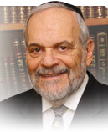

The Torah records for us the years of the life of our mother Sarah. It is done in a lengthy fashion counting one hundred years, twenty years and then seven years, instead of merely stating that she lived for 127 years. Rashi, in his famous commentary, states that this teaches us that that all her years were good ones.

At first glance, this is difficult to understand and accept. In reviewing the life of our mother Sarah, we are aware of the difficulties, dangers and frustrations that marked her experiences in life. Always threatened to be taken and abused by powerful kings, a woman who is barren and longs for children, a wife who has a concubine living in her home and presents her with a stepchild who is uncontrollable, and one who is finally challenged by the fact that her only miraculous child is going to be sacrificed by his own father.

One could hardly conclude that she had a so-called good life. In fact, I would say that most people would not wish such a life experience upon themselves. Yet, we find this to be the pattern in the experiences of all our forefathers and mothers, with very difficult lives. Rashi will later comment that when Jacob wished to have a more peaceful and serene existence, only then did the dispute regarding Joseph and the brothers blossom and explode. Rashi explained there that Heaven somehow is saying that the reward for the righteous is in the eternal world, and that they are, so to speak, not entitled to a leisurely and tranquil life in this world. And yet, in our Parsha, Rashi states that all the years of our mother Sarah, her entire lifetime, can be summed up as a good life.

Over the ages, many thoughts and ideas have been devoted by our great commentators to try and explain this statement and attitude. One of the main ideas is that a person can have a good life only if he or she learns the secret of accepting life in its basic terms and as it occurs. Lofty expectations always bring about disappointment and frustration. Low expectations can allow us to overcome the unavoidable vicissitudes that inflict all human beings during one's lifetime.

Sarah has no illusions about life and about the challenges that she will face, having embarked on the path of her husband Abraham and the founding of the Jewish people. She will view all the occurrences of her lifetime, even those that apparently are negative and dangerous, if not even tragic, with equanimity and fortitude. There is a higher goal that she is striving to achieve, and this goal is always present in her assessment of life.

No matter what occurs in life, it somehow can push her forward on that path towards her ultimate goal. This notion transforms everything that transpires in her life to point towards good and eternity. In her eyes, all her experiences in life had a purpose, a noble one, that transforms the fabric of her life, and enables her to become the mother of Israel for all generations.

*Reprinted from the current website of rabbiwein.com*

**Learning from the Interplay**

**Of Eliezer and the Angel in**

**Making Yitzchak’s Shidduch**

**From the Talks of the Lubavitcher Rebbe**

**Rabbi Menachem Mendel Schneerson, Zt”l**

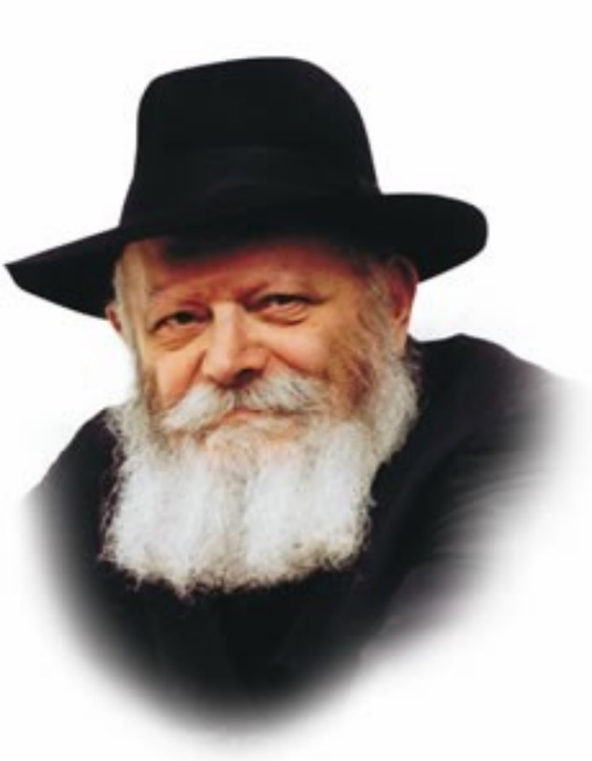

In this week's Torah portion, Chayei Sara, we read of the first shidduch (proposal for marriage) in the Torah.

When Avraham our Patriarch informed his servant Eliezer that he was sending him to find a wife for Avraham's son, Yitzchak, Eliezer was worried. What if the bride he found didn't want to come with him? Thus Avraham reassured him, "G-d...will send His angel before you, and you will take a wife for my son from there."

With these words, Avraham promised Eliezer that his mission would be successful. An angel would precede him on the path; the angel, and not Eliezer, would ensure that the entire matter was affected properly. Eliezer therefore had nothing to worry about, for all the details of his mission would be arranged from Above and were thus out of his hands.

We find, however, that when Eliezer reached Aram Naharayim and asked Betuel's permission for the match, he stated, "And [Avraham] said to me, 'G-d...will send His angel with you, and prosper your way, that you may find a wife for my son.'"

**Eliezer’s Changing the Words**

**Of His Master Avraham**

Why did Eliezer alter Avraham's words? Avraham had promised that an angel would go "before him," yet Eliezer told Betuel that Avraham had said that the angel would go "with him." What is the difference between the two phrases?

By going "before him," the angel, in effect, did all of the work. Avraham promised Eliezer that his steps would be directed from Above, and indeed, this is what happened.

Eliezer experienced a miraculous abridgment of his journey, arriving in Aram Naharayim the very day he set out. When he reached the well and began to pray, no sooner had he uttered the words than Rivkah appeared. Eliezer understood then that his mission had been accomplished, for he realized that the angel had arranged for all of the events and circumstances to fall into place by themselves.

**Not Just an Inactive Bystander**

If, however, Eliezer was merely an inactive bystander, a passive player in the entire affair, it would make no sense for him to tell this to Betuel when asking for his permission for the proposed match. If the match with Yitzchak was already arranged from Above, why would Betuel's permission be necessary?

Thus Eliezer told Betuel that Avraham had promised that the angel would go "with him" -- merely to help him succeed in his mission. In such a case, Eliezer was playing an active role, and Betuel's agreement could then be requested.

*Reprinted from the 5757/1996 Chaya Sarah edition of L’Chaim Weekly. Adapted for Maayan Chai from Likutei Sichos, vol. 25.*

**Heter Mechira**

**By Rabbi Chaim Hillel Raskin**

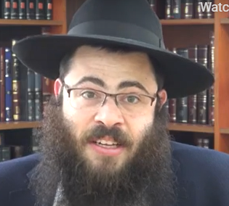

What is “Heter Mechira” and can I purchase produce that relies on this heter? Poskim debate whether the laws of shemita have any application to gentile-owned fields. R. Moshe di Trani (Mabit) ruled that they still have sanctity of shvi’is and must be treated accordingly.1 Beis Yosef argues that in the present age when shemita is rabbinic— since most Jews don’t live in Eretz Yisroel—the produce of gentiles doesn’t have sanctity.2

**A Debate Regarding the Effect**

**Of Gentile Ownership of Land**

Within the opinion of the Beis Yosef, there is debate amongst poskim whether the gentile’s ownership only prevents the produce from having sanctity, or does it totally remove the shemita restrictions, allowing a Jew to work on that property during shemita? The Beis Yosef seems to only discuss the produce, yet R. Yosef di Trani (Maharit, son of the Mabit) holds that a gentile field has no restrictions.3

With the expansion of the Jewish community in Eretz Yisroel in the late 19th century, a debate ensued amongst the halachic authorities whether to allow the Jewish farmers to sell their fields to gentiles—like mechiras chometz—and thereby continue working the fields and selling the produce. The need for the heter was due to the extremely difficult state of the farmers and other residents of Eretz Yisroel. The proponents of the mechira argued that: (a) due to the shaas hadchak, we may rely on a minority view that shemita nowadays is not obligatory; (b) we find that poskim allowed mechiras chometz due to the great need; (c) there are differing opinions regarding the shemita counting, thus creating a safek if this year is in fact the shemita year.

**The Arguments of Those**

**Opposed to the Heter Mechira**

The opponents argued: (a) It is prohibited min HaTorah—due to lo sechanem—to sell property in Eretz Yisroel to a gentile. [The proponents counter that it is only a temporary sale, only a field and not a house, and often done indirectly.4 ] (b) A temporary sale isn’t able to remove its sanctity.5 (c) Mechiras chometz enables you to fulfill the Torah’s directive not to own chometz, while this sale attempts to circumvent the Torah’s desire that the land should rest.6 Some don’t even sell actual chometz in the sale [but we do]. (d) The validity and integrity of the sale is questionable. (e) It is a security concern to sell part of Eretz Yisroel to gentiles.

Practically, the chief rabbinate in Eretz Yisroel allow this heter, but our practice is not to rely on it and the [Lubavitcher] Rebbe was very adamant about that. Yet, the Rebbe wrote that Yidden who don’t plan to observe shemita should at least do some form of sale, and rabbonim should make it as sound as possible.

1 .מבי"ט ח"א סי' כ"א. 2 .שו"ת אבקת רוכל סי' כ"ד, ובכס"מ שמיטה ויובל פ"ד הכ"ט. 3 .ראה מהרי"ט ח"א סי' מ"ג, וראה מנ"ח מצווה של"ד )ומנגד ראה כס"מ הל' תרו' פ"א סוף הי"ג(. 4 .ראה שו"ת משיב דבר ח"ב סי' נ"ו, חזו"א שביעית סי' כ"ג אות ד'. 5 .ראה מנח"י ח"ח סי' צ"ו. 6 .מנח"י שם. 7 .ראה ס' הצאצאים ע' 381 ,אג"ק חט"ו ע' רצ"ז. התקשרות גל' תרפ"ב ע' 7

*Reprinted from the Parshat Vayeira 5782 of the Merkaz Anash’s The Weekly Farbrengen edited by Rabbi Shimon Hellinger.*